

**Software Project 1**

**I farming An E-Commerce Site**

**Submitted By**

|  |  |
| --- | --- |
| 17-35014-2 | Rayhan Sadik |
| 18-37543-1 | Samia Islam Oyse |
| 17-35211-2 | Ashrafur Rahaman |
| 16-32012-2 | Samima Sultana |

**Department of Computer Science**

**Faculty of Science & IT**

**American International University Bangladesh**

**Date of Submission: 3-June-2021**

|  |
| --- |
| **Declaration** |

We declare that this thesis is our original work and has not been submitted in any form for another degree or diploma at any university or other institute of tertiary education. Information derived from the published and unpublished work of others has been acknowledged in the text and a list of references is given.

|  |  |
| --- | --- |
| ____________________  **Samia Islam Oyse**  AIUB ID: 18-37543-1  Department: CSSE | ______________________  **Rayhan Sadik**  AIUB ID: 17-35014-2  Department: SE |
| ____________________  **Samima Sultana**  AIUB ID: 16-32012-2  Department: CSSE | _____________________  **Ashrafur Rahaman**  AIUB ID: 17-35211-2  Department: SE |

|  |
| --- |
| **Approval** |

The thesis titled “I farming An E-Commerce Site” has been submitted to the following respected members of the board of examiners of the department of computer science in partial fulfilment of the requirements for the degree of Bachelor of Science in Computer Science on (**3-June-2021**) and has been accepted as satisfactory.

|  |  |
| --- | --- |
| _______________________________  **MD. SADRUL AMIN**  Team Lead, System Analyst & Supervisor  Department of Computer Science  American International University-Bangladesh | _______________________________  **MD MASUM BILLAH**  Faculty, Lecturer & External  Department of Computer Science  American International University-Bangladesh |
|  |  |
| _______________________________  **Dr. Md. Mahbub Chowdhury Mishu**  Rank & Head (Undergraduate)  Department of Computer Science  American International University-Bangladesh | _______________________________  **Professor Dr. Tafazzal Hossain**  Dean  Faculty of Science & Information Technology  American International University-Bangladesh |
|  |  |
| _______________________________  **Dr. Carmen Z. Lamagna**  Vice Chancellor  American International University-Bangladesh | |

|  |
| --- |
| **Acknowledgement** |

First of all we would like to thank almighty Allah, for his grace in accomplishing our Software

Project 1 (SP1) documentation timely.

We would like to express our gratitude to the department of Computer Science to keep Software

Project 1 credit in the curriculum of the graduation program and give us a scope of doing a project with our interest. We are also grateful to the department of Computer Science to arrange an opportunity for us to choose a project and complete the documentation in this subject.

We are thankful to our supervisor MD. SADRUL AMIN From the core of our hearts for his continuous kind support, guidance, constructive supervision, instruction and advice and for motivating us to do our Software Project 1 under him. We would also like to convey our gratitude to our honorable Vice Chancellor, Dr.Carmen Z.Lamagna, our honorable Associate Professor & Director of Computer Science Dr. Dip Nandi, our Department Head honorable Dr. Md. Mahbub Chowdhury Mishu and our Dean Professor Dr.Tofazzal Hossain Faculty of Science & Information Technology, American International University-Bangladesh.

|  |
| --- |
| **Abstract** |

This project is basically for breaking the syndicate and black-market out there. This project will open a window between the farmers and the consumers that significantly manipulate the Agri-product trades and communication. First the farmer have to sign-up and pay the subscription amount. Similarly, the consumers have to do the same. After doing this they both are good to go to use the software. After that farmers can easily sell their products at the highest price fixed the government. Consumers can also buy the product at the same price. As there is no existence of syndicate the farmers get the highest profit and also the consumers can consume products at a very hence same price. There will be a product quality check-option as well. This will benefit both the farmers and consumers.

|  |
| --- |
| **TABLE OF CONTENTS** |

**Chapter 1: Project Scope**

1.1 Introduction …………………………………………………………………... 5-6

1.2 Background of the problem ……………………………………………………. 6

1.3 Objective …………………………………………………………………......... 7-8

1.4 Problem Solving ……………………………………………………………….. 8

1.5 Existing Project of Market …………………………………………………….. 8

1.6 Our Solution VS Other Solution ………………………………………….….... 8-9

1.7 Project Requirement …………………………………………………………..... 9

**Chapter 2:** **Project** **Specification**

2.1 Product Perspective ………………………………………………………….. 9-10

2.2 User Classes and Characteristics ……………………………………………… 10-11

2.3 Design and Implementation Constraints …………………………………….... 11

2.4 Operating Environment ………………………………………………………. 12

2.5 Feature of this Project ………………………………………………………….... 12

**Chapter 3:** **System Requirement Specification**

3.1 Business Requirements ……………………………………..………………… 13

3.2 System Features ……………………………………………………………..... 13

3.3Functional Requirements ……………………………………..………………. 13-15

3.4 Non Functional Requirements ……………………………………..………… 15-16

3.5 User Stories ……………………………………..……………………………. 16-19

**Chapter 4:** **System Design** **Specification**

4.1 Flowchart Diagram ……………………………………..…………………… 20

4.2 Use Case Diagram ……………………………………..……………………. 21

4.3 Class Diagram ……………………………………..………………………… 22

4.4 Activity Diagram ……………………………………..…………………. 22

4.5 ER Diagram ……………………………………..………………………. 23

4.6 Admin Data Flow Diagram ……………………………………..………. 24

4.7 Buyer Data Flow Diagram ……………………………………..……….. 25

4.8 Farmer Data Flow Diagram ……………………………………..…… … 26

**Chapter 5:** **Software Project Management Plan**

5.1 Project Estimation ……..………….………………27

5.2 Project Budgeting ……..………………………………………………. 28-29

5.3 Project Scheduling ……..………………………………………………. 29

5.4 Risk Assessment………………………………………………………… 30-32

5.5 List of Test Case ……..……………………………………………........ 33-37

5.6 Database Format ……..………………………………………………… 38

5.7 User Interface……………………………………………………….…... 39-43

**Conclusion**…………………………………………………………………...43

**References**……………………………………..…………………………….43

|  |
| --- |
| **List of Tables** |

**3.5**

**Table 1-A**  System Login.. ………………………………………………....18

**Table 1-B** Admin Roles………………………………………………….....18-19

**Table 1-C** Consumer Roles………………………………………………....19-20

**Table 1-D** Consumer Roles………………………………………………….20

**Table 5.2-A**  Project Budget...............................................................................29-30

**Table 5.3-B** Activity Network Diagram.............................................................31

**Table 5.4-C** Risk Assessment.............................................................................32-33

**Table 6-A** Test Case for User Registration........................................................35-36

**Table 6-B** Test Case for User Login..................................................................36

**Table 6-C** Test Case for User Homepage...........................................................37-38

**Chapter 1**

**1.1 Introduction:**

Agriculture is the most significant employment sector in Bangladesh. The performance of this sector has an overwhelming impact on primary macroeconomic objectives like employment generation, poverty alleviation, human resources development, security food, etc. A plurality of Bangladeshi farmer earns their living from agriculture. So this project plays an influential role in our agricultural system.

This project will help both the farmers &amp; the consumer to directly buy the Agri-Product at an accessible price from the farmers. The farmers can get the maximum price of their produce without brokers. That is why our farmers will not face any financial syndicates, and buyers will get the actual product. This project will also help to reduce “Black-Marketing” activities as the number of stored Agri-Products. Farmers can get any help regarding crop productions, procurement requirements from the government, and many more. To keep the same price range, this solution will follow International trade law in which governmental price range will be fixed; within that price range, consumers must buy the Agri-produces &amp; farmers must sell their products.

This solution will be free from intermediaries meddling so that no troubles will occur in the price between the consumers and the farmers.

**1.2 Background of the problem:**

The most common problems with the farmers have little knowledge of marketing their produce products. Farmers are reluctant to share their land or work in a familiar land for growing agricultural commodities.

Every year Farmers of Bangladesh face a few regular cruxes like Loss of Arable Land, Population Growth, Climate Changes, Inadequate Management Practices (Fertilizer, Water, Pests, and Diseases), Lack of Quality Seeds, Inadequate Credit Support to Farmers, Insufficient Investment in Research, and many more. Farmers often face two major problems; first, they are often unable to meet the procurement requirements of the government and the second most important one is that they cannot sell theirs produces at a price fixed by the government. Farmers of Bangladesh belong to small and marginal categories. As the farmers don’t have any Farmer’s Association or Farmer’s Co-operative, they cannot even bargain for fair prices of their produce. They have been forced to sell their products at low prices to intermediaries (brokers) as having no other options; thus, many future cruxes arise. That is why farmers could not get the actual value of their product. Some of them came to Dhaka from a long distance to sell their products which is a long journey for their business. For the long-term trip, some of their products were not fresh as the previous item. For this reason, consumers could not get new products. Sometimes they are attacked by hijackers and snatchers, which is so risky for their life. This problem is growing day by day. Now, this is the time to recover these problems through our alternative system.

**1.3 Objective:**

1. Bangladesh Government should keep intermediaries (brokers) away from Agri-trading and imply a fixed price for crop trading worldwide. Government must suggest laws for trade and commerce against black marketing so that, Farmers can sell their products directly to the consumers with the maximum profit, and consumers can buy the product at the fair price fixed by the governments.
2. The main thing of this project is to help farmers ensure greater profitability through direct farmer to end-user communication. This project aims to create opportunities for the farmers to maximize their profits by selling their products directly to the consumers. This web application is the solution that will create opportunities for the farmers and also will help the government, farmers, and consumers to keep intermediaries away from Agri-Marketing and to regulate the price varying so that price will be the same all over the state and consumers can buy at an accessible price.
3. An effective agriculture-E-commerce solution can extend the business by increasing opportunities with customers, suppliers, and other farms.

**1.4 Problem Solving:**

As our project is related to farmers and agriculture, we must deal with many problems. Solutions to these problems are one of our primary concern as we can see, the most widespread problem is that farmers cannot do marketing their products. As a solution, we will make a platform to do advertisements and market their products by signing up for our website. They can be our priority seller; they can advertise their products with a bit of advertisement money.

Every year, they face some serious issues like a shortage of water and antipasti fertilizer. We will guide them about what to do in this crisis, and we will manage the fertilizer from another seller with good in a margin of money. Sometimes, the lack of quality seeds and inadequate money for plowing the lands. In this case, we will try to guide them by informing them how to make quality seeds within our climate if they are our regular and priority sellers. We will try to arrange for them some loans with fewer terms and conditions. One of the significant problems they face is they cannot sell their product within the minimum price fixed by the government. This problem happens because the brokers buy crops from farmers at a meager price and sell them to wholesale sellers. Because of these two or three middle people, the retail amount remains the same or slightly higher, but the farmers get significantly less amount they deserve. By using our platform, they will not face these kinds of problems. We will make a bridge from farmer to customer by eliminating third parties. By this procedure, it will benefit them from both sides. Sometimes the farmer comes to Dhaka from their villages to sell their goods. They face a massive hassle. As well as, the crops don’t remain fresh as they were by using our platform. They can directly deliver their products without any hassle.

**1.5 Existing Project of Market:**

There are many online Agri-market related websites in different countries in the current market. For example, Portugal has its website that directs trading communication between farmers and buyers. (https://agrimp.com/) where farmers can sell their products directly to industrial buyers and can make a safe transaction with maximum profits. Neighbor country India has some online startup solutions like ([https://Bighaat.com/)for](https://bighaat.com/)for) farmers where farmers can buy and can get help regarding farming from the online experts. Another Indian startup (https://Agribazaar.com/) helps their farmers to sell their Agri-Products through an online digital system that will remove intermediaries from the inside trading. Bangladesh-based Agri-Products help startup (https://www.ifarmer.asia/) used to help farmers to assists in farming where farmers can sell their Agri-Products in a bulk amount directly to the buyers.

**1.6 Our Solution VS Other Solution:**

Most of the Argo-Market websites sell the Argi-product needed for agricultural work from farmers on their website. Also, they work as third parties; they buy at a lower price from farmers and sell at a higher price on their website. Some websites are communicating directly between farmers and buyers. However, farmers will be able to advertise the sale of their fresh produce directly on our website. We will not have any communication with the farmers; the farmers will communicate with the buyer and sell their product. This is the main difference between our website and other websites. We connect farmers directly to the buyer with complete control of the supply. We do not buy or sell crops, and we are not brokers. Instead, we offer the opportunity to advertise products through our platform.

**1.8 Project Requirement:**

1. Computers or Laptops
2. SQL Database
3. Internet Browser
4. Operating system: Windows (8-10)
5. Lucid chart Diagram Software & Visual Solution

**Chapter 2**

**2.1 Product Perspective**

This e-commerce website is a digital trading solution that will bring Farmers and consumers together for Agri-Marketing communication. It does not buy or sell crops and is not a broker. Instead, it will offer the ability to market your products via an online system platform effortlessly. There will accommodate direct transactions through this website between consumers and the farmers. This website covers all intermediate supply chain stages. This software system will be a user-friendly system for its users to use the system for accessible communication and trading easily. There are no illegal transactions between consumers and farmers. Hats because they will get the proper value of their product. The system will have three primary users

1. Admin,

2. Consumer and

3. The seller (farmer)

Here Consumers and Sellers will play the most critical and vital role in this project. Admin will monitor the complete system, other users, consumers, farmers, and post activities. Consumers who are generally ordinary people and can buy the Agri-Product using the system, as per their needs envisaging the sell posts posted by the farmers who will appear in their dashboard. Farmers who can post their sell advertisement to sell their Agri-Products directly to the consumers. If any customer wants to buy this product, then he can bid this product for 1 hour. If the seller wants to sell his product for that customer, he will give the sell request to the admin. Then admin approves his sell request, and customer can buy their preferable products.

How it will work:

1. Sign-up to the platform.

2. Create your advertisement or bid.

3. Set a quantity &amp; price.

4. Provide with crop characteristics &amp; details.

5. Edit their vital details.

6. Decide upon logistic and/or crop quality check services.

7. Post your seller offer or buyer bid.

8. Stay updated by phone calls, email, or notification center.

**2.2 User Classes and Characteristics:**

Our system will have three primary users and some secondary users. There are three types of prior users in our system. They are admins, sellers, and buyers. The three primary users will play an essential role in our system. The whole project has been built here with buyers and sellers in mind, and both are playing a vital role in this project. Secondary users are Delivery men or consumer good delivery companies.

Firstly, the Admin will monitor and control the entire system, follows the complete process of a transaction between the seller and the buyer, monitor all user post activities. Secondly, the buyers, who are generally ordinary people and can buy the Agri- Product using the system, as per their needs envisaging the sell posts posted by the farmers, which will appear in their dashboard. Thirdly an essential user is Farmers who can post their sell advertisement to sell their Agri-Products directly to the buyers without intermediaries meddling. Like general unemployed people working as delivery men, other secondary users can use the system for making trading easy between the farmers and the buyers.

**2.3 Design and Implementation Constraints:**

As the system will be used by the farmers so there is a chance that they may not understand how to use the system, they may not be familiar with digital I-Farming. There is a chance that not all consumers will use the system as more common people likes to buy the products from the market in an orthodox style. The system may not be user-friendly for the farmers, and they may get puzzled. The developer may face some trouble designing the database and Graphical User Interface as they may not have experience as they don’t have work on the same type of project before. Developing time may be extended or expired. For example, there the six significant problems encountered with the project-

1. Production technology deficient
2. Poor engineering
3. Wrong organizational structure
4. Too many components
5. Over-dimensioning
6. Improving design

**2.4 Operating Environment**:

An operating environment is an environment in which users run application software. The environment consists of a user interface provided by an applications manager and usually an application programming interface (API) to the applications manager.

An operating environment is usually not a complete operating system but is a form of middleware that rests between the OS and the application.  The system will be platform-independent to run on any operating system such as Windows, Mac, Linux, etc. It can be accessed through the URL link as a website and can search by any search engine like Yahoo, Google, or any other user any browser such as Chrome, Firefox, Microsoft Edge, etc. Hardware such as computer desktops or laptops, android or IOS devices, keypad phones is needed to execute the program. Users can use the application both using online and offline services.

**2.5 Feature of this Project:**

1. Create account
2. Sign in
3. Start selling
4. Edit profile
5. Search
6. Contact
7. Edit and remove posts
8. About website
9. Forgot password
10. Filter
11. All Categories
12. Tags
13. Bidding system
14. Cart system

**Chapter 3**

**3.1 Business Requirement (Organizational benefit):**

We are developing this website to bring a significant change in the farmer and consumer trading by the broker and bring a massive change in the economic market. Farmers can earn maximum profit by selling their Agri products directly to the consumers through this website. Developing this project can solve the Agri -produces price difference problem. It will help farmers to fulfill customers demand by producing and supplying the correct number of products. For this, the customer can get fresh Agri products and lead a healthy life. Also, farmers can quickly sell their new products without risk and save their valuable time.

**3.2 System Features:**

The system should be able to execute some significant feature like:

1. All the users must Register or sign-up.

2. For using the system, the user has to log in.

3. Admin can access all the User records and can add and remove any user.

4. Admin can see the number of posts and can approve or disapproved, or removed any user post.

5. User (Farmer) can upload sell posts &amp; also can buy products.

6. User (Farmer and consumer) can see their Trading records and can add, edit, remove, and update their posts.

7. User (Farmer) can make a bid for a limited time.

8. User (Farmer) needs approval from admin in payment issue.

9. User (consumer) can make payment through admin.

**3.3 Functional Requirements**:

1. Register or sign-up: Functional Requirements for Register or Sign-up:

1.1 The software shall allow users to Register or sign-up with their Full Name, User Name, Phone number, Email address, Password, Confirm Password, and User Type.

1.2 User must provide all the upper information; the only farmer can skip providing mail information.

1.3 If any of the upper information missing systems will not be submitted and it will notify the user to submit all the information.

1.4 All information will save in the database system. Priority Level: High

2. Software Login Functional Requirements for Login:

2.1 The software shall allow users to log in with their given username and Password

2.2 If the username and/or Password has been inserted wrong, then the user needs to go forgot password option

2.3 If the number of login attempt exceed its limit (5 times), the system shall block the user account login for one hour [optional function]

Priority Level: High

Precondition: user must have valid user id and Password

3. User Management: Functional Requirements for user management

3.1 The system shall allow the admin user to add, delete, and edit the other user and staff (Farmer and consumer) user information with the user ID, Password, username, photo, phone number, and email address.

3.2 The system shall allow the admin to see the number of posts and can approve or disapproved, or removed any user post.

3.3 Farmer User (Farmer) can upload sell posts &amp; also can buy products

3.4 User (Farmer and consumer) can see their Trading records and can add, edit, remove, and update their posts

3.5 User (Farmer) can make a bid for selling their product for a limited time.

3.6 user (customer) can use a filter system for buying products.

3.4 user (customer) can use the cart when they want to buy anything from the website

Priority Level: High

**3.4 Non-Functional Requirements:**

Non-functional means it does not directly impact the project, but our project will be incomplete without those functions.

Usability: As the software will be for farmers so, it must maintain the utmost user-friendliness. The user must feel at ease to use the software, and the system must be quick to interact with the user.

Serviceability: Serviceability requirements are a set of conditions under which a foundation structure is sound.

Security: A security requirement is a security feature required by system users or a quality the system must possess to increase the users trust in the system they use.

Capacity: Capacity requirements planning is how a website figures out how much it needs to produce and determines if it is capable of meeting those production goals.

Availability: For this report, an Availability Requirement is any requirement that is not a functional, data, or process requirement concerned with defining the periods we can use the solution.

Scalability: Scalability refers to the ability of the environment to meet the needs of an increasing number of users and external services in a way that is predictable in terms of performance.

Interoperability: A definition of interoperability is the ability to share information and services.

Reliability: A reliability requirement is a prediction or forecast of the products performance in the future. Reliability is usually defined as the probability that a product will operate without failure for a specified number of uses (transactions) or a specified period.

Maintainability: Maintainability is the ease with which faults in a software system can be found and fixed.

**3.5 USE STORIES:**

**Table 1-A: System Login**

|  |  |
| --- | --- |
| Use Case Name | Login to system |
| Use Case ID | UC_1 |
| Use Case Type | Functional Requirement |
| Priority | High |
| Primary Business Actor | User (Admin, , Consumer, Farmer) |
| Other Interested Stakeholders | None |
| Description | This use case describes how to enter into the System. By giving some details like User ID (email), and password user can check the validation and enter into the system. |
| Precondition | The user must be valid by register. |
| Trigger | The use case is initiated when a user tries to enter in the system. |
| Typical Course of Events | Step 1: The user input username, password, email, mobile no and address  Step 2: By click on login a validation process is run by the system  Step 3: If the user name and password is matched the user can go to ordering page to purchase their items. |
| Conclusion | The use case concludes when the entry operator gets an order confirmation message from the system. |

**Table 1-B: Admin roles**

|  |  |
| --- | --- |
| Use Case Name | Admins responsibilities |
| Use Case ID | UC_2 |
| Use Case Type | Functional Requirement |
| Priority | High |
| Primary Business Actor | Admin |
| Other Interested Stakeholders | Buyer, seller |
| Description | This use case describes the role of Admin in the system that he can add and remove any users, he can remove any post etc. |
| Precondition | The admin must have valid user account. |
| Trigger | none |
| Typical Course of Events | Step 1: This functionality will help admin to add and discard user.  Step 2: Admin can remove any user account at any time.  Step 3: After a successful operation, the admin will be notified by the  system message. |
| Conclusion | The use case concludes after a successful message. |

**Table 1-C: Consumer roles**

|  |  |  |
| --- | --- | --- |
| Use Case Name | Consumer role | |
| Use Case ID | UC_3 | |
| Use Case Type | Functional Requirement | |
| Priority | | High | |
| Primary Business Actor | | Consumer (buyers) | |
| Other Interested Stakeholders | | Admin and farmers | |
| Description | | Using the system consumers can buy the Agri-Products. | |
| Precondition | | Consumers must have valid user account. | |
| Trigger | | none | |
| Typical Course of Events | | Step 1: Using the system consumer can check out the products available in the system.  Step 2: Buy clicking on “Add to Cart” if the consumer press confirm then can buy the products.  Step 3: Consumer can see their trading records.  Step 4: Consumer can check out the limited time offers of products.  Step 5: Consumers must pay a little amount of money for buying his products in advance. | |
| Conclusion | | The use case concludes after a successful message. | |

**Table 1-D: Consumer roles**

|  |  |  |
| --- | --- | --- |
| Use Case Name | | Consumer role |
| Use Case ID | | UC_4 |
| Use Case Type | | Functional Requirement |
| Priority | High | | |
| Primary Business Actor | Farmer (Sellers) | | |
| Other Interested Stakeholders | Admin and Consumers | | |
| Description | Using the system Farmers can sell their Agri-Products to the consumers. | | |
| Precondition | Farmers must have valid user account. | | |
| Trigger | none | | |
| Typical Course of Events | Step 1: Using the system farmers can give Ad of their products  Step 2: If any consumer added the product in the cart and confirm it then farmers can sell their products to them.  Step 3: farmers can see their trading records.  Step 4: farmers need to get an approval from admin when he wants to collect his payment. | | |
| Conclusion | The use case concludes after a successful message. | | |

**Chapter 4**

**4.1 Flowchart diagram:**

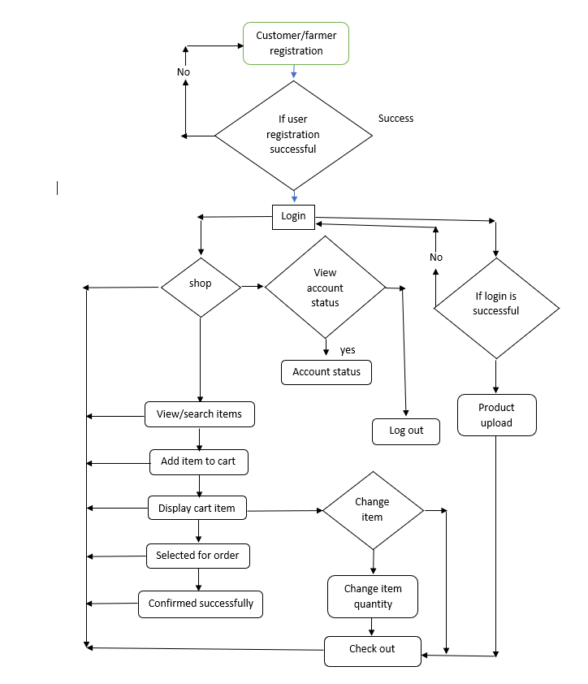

**Figure 4.1: Flowchart diagram**

**4.2 Use case diagram:**

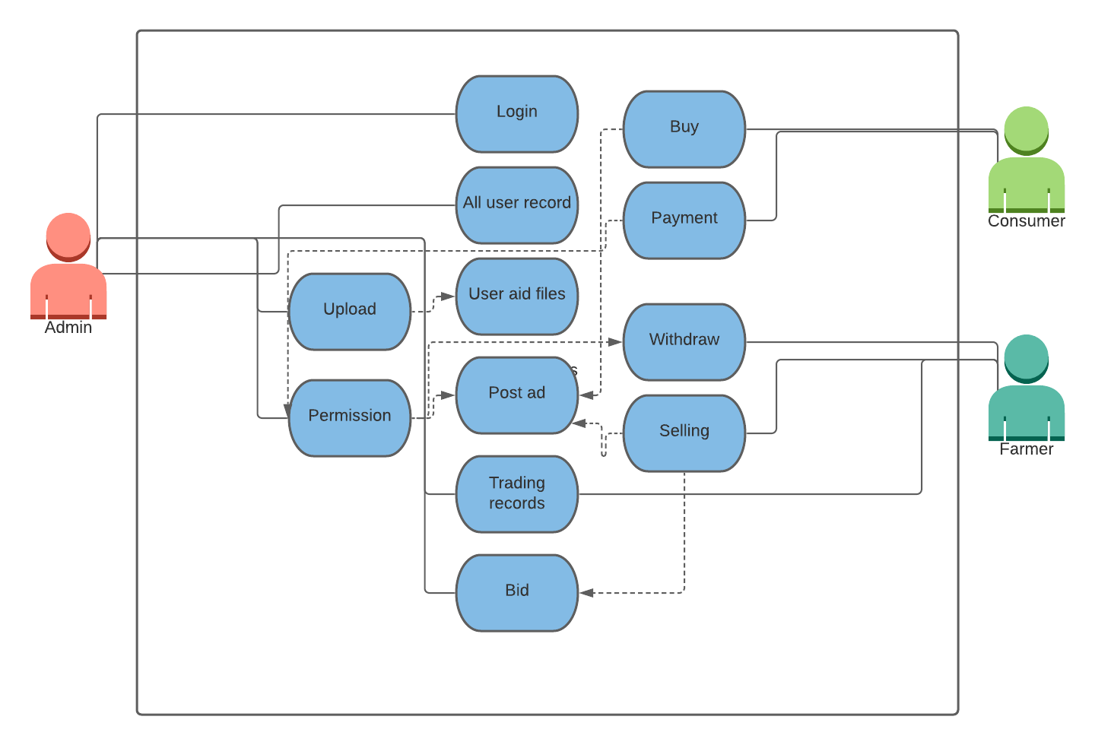

**Figure 4.2: Use case diagram**

**4.3 ER diagram:**

**Figure 4.3: ER diagram**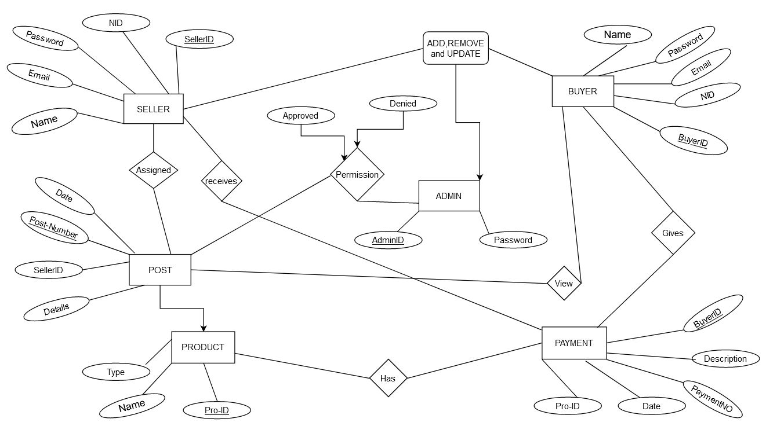

**4.4 Class Diagram:**

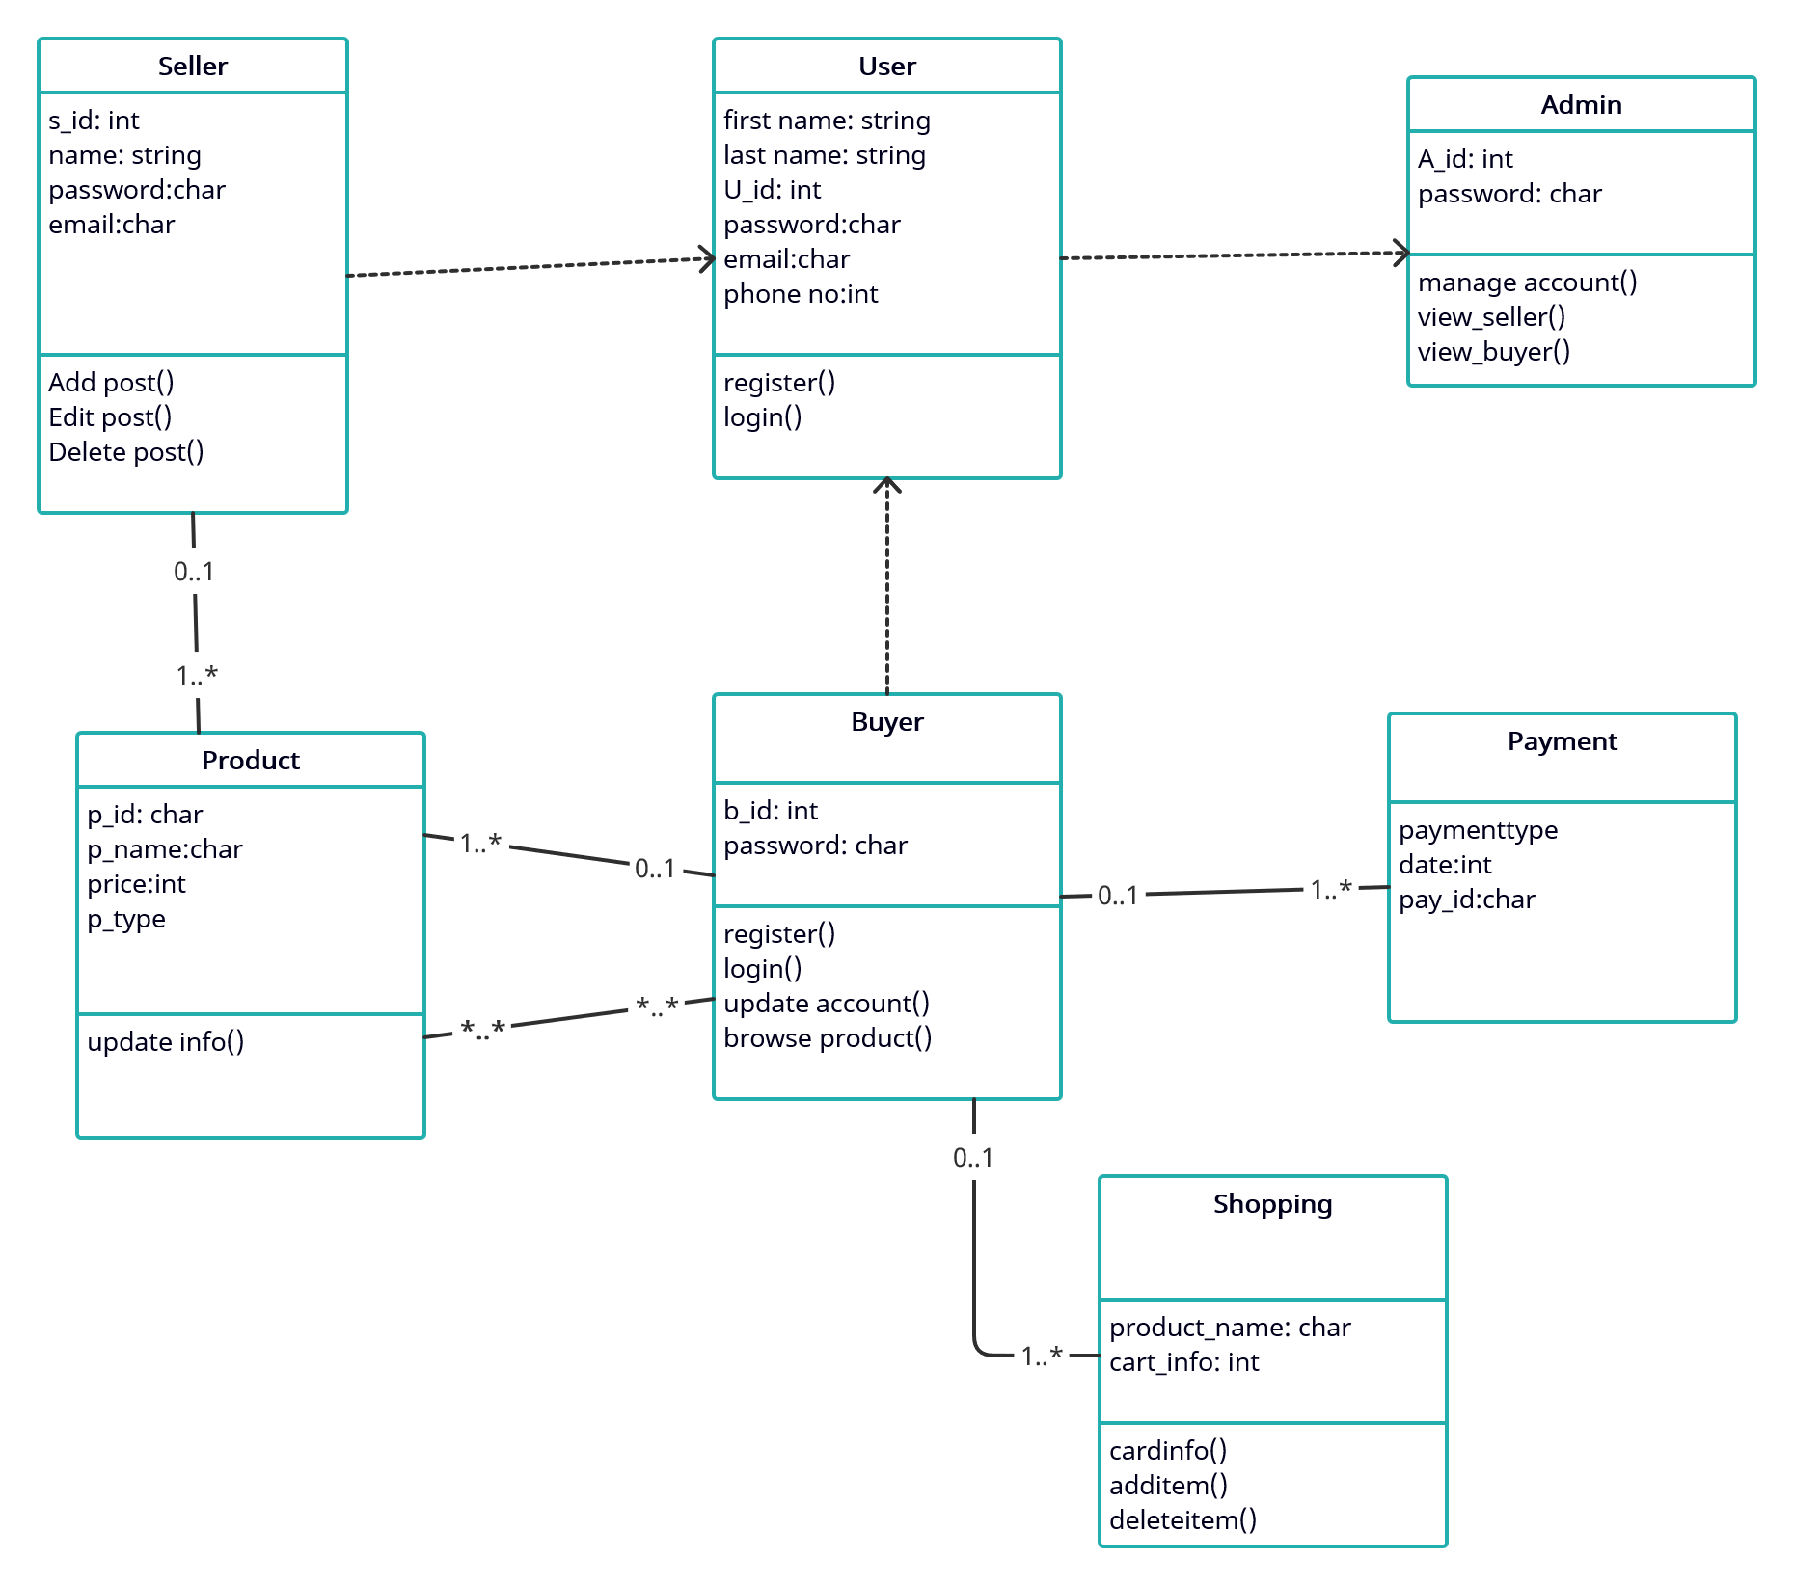

**Figure 4.4: Class diagram**

**4.5 Activity diagram:**

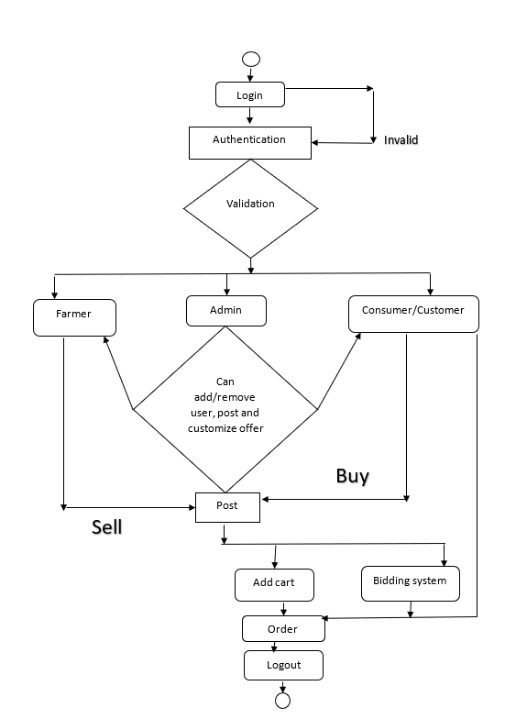

**Figure 4.5: Activity diagram**

**4.6 Admin Data Flow Diagram:**

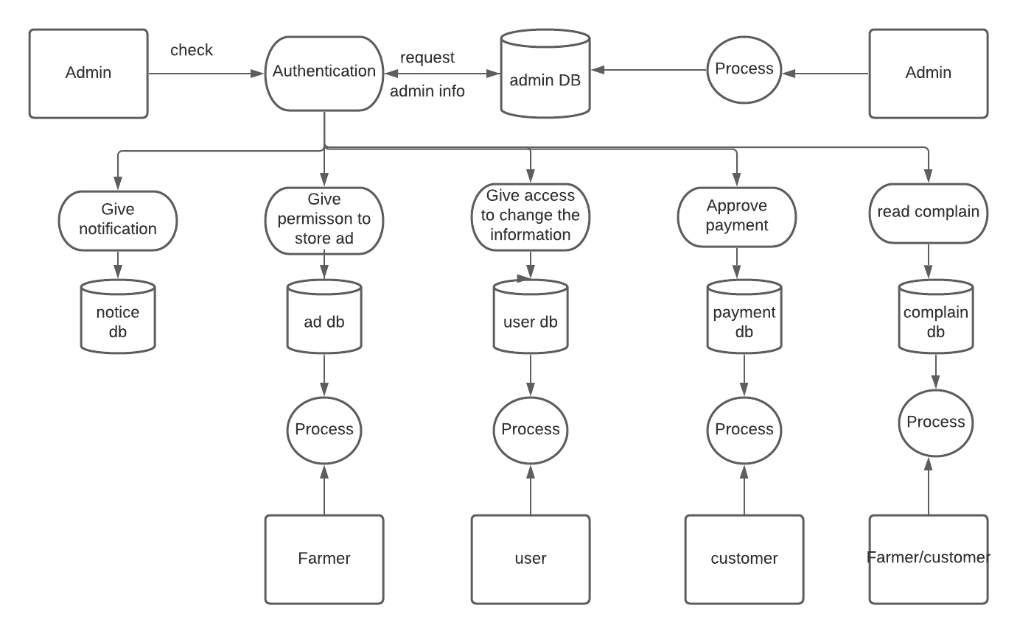

**Figure 4.6: Admin Data Flow Diagram:**

**4.7 Buyer Data Flow Diagram:**

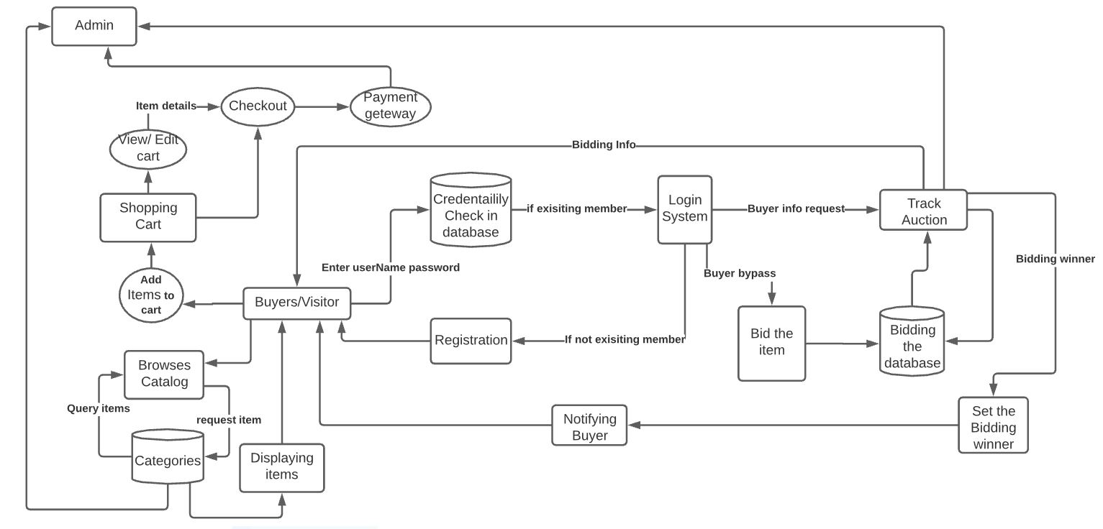

**Figure 4.7 Buyer Data Flow Diagram**

**4.8 Farmer Data Flow Diagram:**

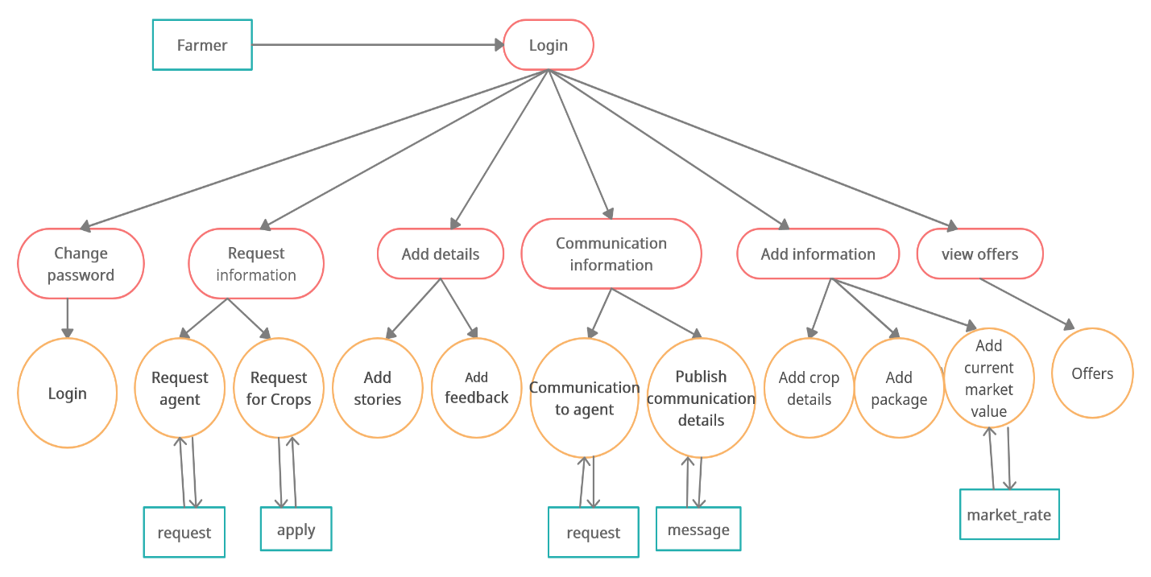

**Figure 4.8 Farmer Data Flow Diagram**

**Chapter 5**

**5.1 Project Estimation:**

For estimation we used Co-Co-Mo (Constructive Cost Model)

COCOMO (Constructive Cost Model) is a regression model based on LOC, i.e., number of Lines of Code. It is a procedural cost estimate model for software projects and often used as a process of reliably predicting the various parameters associated with making a project such as size, effort, cost, time, and quality.

Our Project is a Semi- Detached system for which

Coefficient<effort factor > = 3.0

Complexity, P = 1.12;

SLOC dependent coefficient, T = 0.35;

SLOC = 8000;

Effort = PM = Coefficient<Effort Factor>*(SLOC/1000) ^P

= 3× (8000/1000) ^1.20

= 36 person-months

Development Time, DM = 2.5× (PM) ^T

= 2.5× (36) ^0.35

= 8.76 ≅ 9months = 36weeks (about 8 and a half months)

Required number of People, ST = PM/DM

= 36/79

= 4 Persons

**Table 5.2-A: Project Budget**

|  |  |  |  |
| --- | --- | --- | --- |
| **Service** | **Quantity** | **Amount** | **Total** |

|  |
| --- |
| **1. Project Team Costs** |

|  |  |  |  |
| --- | --- | --- | --- |
| Programmers | 2 persons | ৳ 20,000 | ৳ 40,000 |
| Testers | 2 persons | ৳ 20,000 | ৳ 40,000 |
| Training Staff |  | ৳ 12,000 | ৳ 10,000 |

|  |
| --- |
| **2. Software relevant Charges** |

|  |  |  |  |
| --- | --- | --- | --- |
| User & database licenses |  | ৳ 50,000 | ৳ 50,000 |

|  |
| --- |
| **3. Hardware Costs** |

|  |  |  |  |
| --- | --- | --- | --- |
| Laptops and other devices |  | ৳ 1,50000 | ৳ 1,50000 |
| Printers | 2 | ৳ 5,000 | ৳ 10,000 |

|  |
| --- |
| **4. Network Costs** |

|  |  |  |  |
| --- | --- | --- | --- |
| Routers & Internet connection |  |  | ৳ 20,000 |
| Dedicated Domain address |  |  | ৳ 2000 |

|  |
| --- |
| **5. Labor Costs** |

|  |  |  |  |
| --- | --- | --- | --- |
| Implementation, system installation, documentation |  |  | ৳ 30,000 |

|  |
| --- |
| **6. Logistics Costs** |

|  |  |  |  |
| --- | --- | --- | --- |
| Staff costs |  |  | ৳ 25,000 |
| Information System department |  |  | ৳ 10,000 |
| Legal assistance & advices |  |  | ৳ 10,000 |

|  |
| --- |
| **Total = 397000 ≅ 400000** |

**5.3 Project Schedule**

**Work Breakdown Structure**

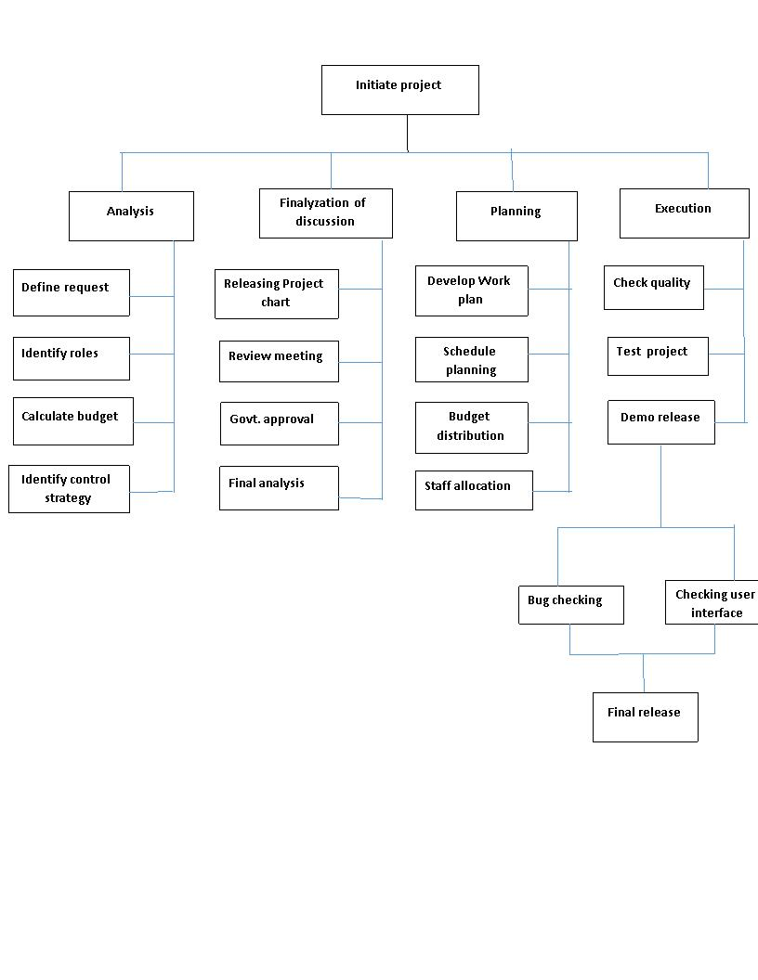

**Table 5.3 –B:**

**Scheduling shall be implemented through activity network diagram**

|  |  |  |
| --- | --- | --- |
| **Label** | **Activity** | **Duration** |
| A | Requirement Identification | 5weeks |
| B | Project Estimation | 5weeks |
| C | planning | 4weeks |
| D | Design | 4weeks |
| E | Execution(coding) | 8weeks |
| F | Testing | 4weeks |
| G | Analyzing Customer Feedback | 4weeks |
| H | Final Release and Handover | 2weeks |

**Table 5.4 –C: Risk Assessment:**

**Risk Information Sheet**

|  |  |  |  |
| --- | --- | --- | --- |
| **Risk ID** | **Description** | **Probability** | **Impact** |
| Risk_ID_1 | Software team does not have valuable experience in programming language | 40% | Medium |
| Risk_ID_2 | Technology will not meet expectation | 20% | Low |
| Risk_ID_3 | Stuff turnover will be high | 70% | Critical/High |
| Risk_ID_4 | Customer will change Requirement | 50% | Medium |
| Risk_ID_5 | Project will outrun the allocated Budget | 80% | Critical/High |
| Risk_ID_6 | Farmers may not understand system uses | 60% | Medium |

|  |  |  |
| --- | --- | --- |
| Risk_ID_1 | Probability: 40% | Impact: Medium |
| Description: Software team does not have enough experience  Mitigation plan: Organize a 5day training program and build a prototype database  Monitoring and Management: Track progress of the developers on weekly basis until the team has confidently tested the prototype  Status: Initial Identification | | |

|  |  |  |
| --- | --- | --- |
| Risk_ID_2 | Probability: 20% | Impact: Low |
| Description: Technology will not meet expectation.  Mitigation plan: Optional technology or devices should be kept as a backup plan.  Monitoring and Management: Checking or testing a demo project on the backup technologies whether the system will work or not.  Status: Initial Identification | | |

|  |  |  |
| --- | --- | --- |
| Risk_ID_3 | Probability: 70% | Impact: Catastrophic / high |
| Description: Stuff turnover will be high  Mitigation Plan: Make sure that tasks are equally divided between the available staff, so that no one has overload of work and keeping backup person for every and each employee.  Monitoring and Management: Keep a close on the emotions of the employee and their concentration on the work, how much effort they are putting in it.  Status: Initial Identification | | |

|  |  |  |
| --- | --- | --- |
| Risk_ID_4 | Probability: 50% | Impact: Medium |
| Description: Client will change requirements  Mitigation Plan: Ensuring that the requirements are stable and collected at the requirement elicitation period.  Monitoring and Management: Informing client to about the changing effects of the requirements at the middle of the project would delay the project may failed the project.  Status: Initial Identification | | |

|  |  |  |
| --- | --- | --- |
| Risk_ID_5 | Probability: 80% | Impact: Catastrophic / high |
| Description: Budget running low before the end of final deliverables  Mitigation plan: Decide to keep the spending within check, not trying not to spend too much on technologies that add no extra value to the outcome of the project.  Monitoring and Management: Keep the amount left in hand on regular checks as well as make sure no extra bucks are being spent on gold plating. | | |

|  |  |  |
| --- | --- | --- |
| Risk_ID_6 | Probability: 60% | Impact: Medium |
| Description: Farmers may not understand system uses  Mitigation plan: Printing user manuals and organizing workshop or training session for the users so that they can uses the system or the apps.  Monitoring and Management: Management should make documentation video so that users especially farmers can learn how to use the system by those documentation videos. | | |

**List of Test case:**

The E-commerce website ifarming home page should contain the major items Register and Login page. Clicking on Register, system will take the user to Registration (Create Account) page. By clicking on Login system will take the user to the Login page. User must register themselves first. In the register page there will be a table called “Register Here” will appear in which user has to provide their name, contact details, Passwords, and address then they must submit the form which will store in the database. If user previously registered their account a below provided button will take them to login page in which they have to login with their user id and password.

**Requirements (Partial) for the ifarming**

**Register:**

1. By clicking on “Register” a new page called “Register Here” will appear
2. The website ifarming home Register page should contain the major item Register and in the register table there will be various kinds of placeholder such as Name, Phone number, Email address, Password, Confirm Password, NID Number, User Type and Submit button.
3. In the Register form user must provide or write their personal details such Full Name, Phone number, Email address, Password, Confirm Password, NID Number, and User Type in the allocated placeholders.
4. After filling up all the placeholder details user will click “Submit” button for saving user’s information in the database and then user has to login to their account after which system will take the user to their respective index or dashboard page.

**Table 6-A:**

|  |  |  |  |  |  |
| --- | --- | --- | --- | --- | --- |
| **Test Case for User Registration** | | | | | |
| **Project Name:** | | | **Date Of Creation:** DD-MMM-YY. | | |
| **Module Name:** User Registration | | | **Date Of Review:** DD-MMM-YY. | | |
| **Test Case Id:** Tc_Registration_001 | | | **Test Case Scenario:** Registration to the system. | | |
| **Precondition**: Enter valid email id.  Enter valid user name,  Enter Valid personal information. | | | | | |
| **Step** | **Test Steps** | **Test Data** | **Expected Result:** | **Actual Result**: | **Status (Pass/Fail):** |
| 1 | Enter user name. | <Valid Username> Not <Invalid Username> |  |  |  |
| 2 | Enter email id. | <Valid Email Address> Not <Invalid Email Address> |  |  |  |
| 3 | Enter password. | <Valid Password> Not <Invalid password> |  |  |  |
| 4 | Enter personal information. | <Valid Personal Information> Not < Invalid Personal Information> |  |  |  |
| 5 |  |  |  |  |  |
| **Post Condition:** Useris validated with database and successfully login to account.  The account session details and logged in database. | | | | | |

**Login:**

**1**. Register is the pre requisite of Login. User must register or sign up first to do further Login.

**2.** For login into the user account system will require User ID and user password. Email address or mobile number will be User ID. There will be an email or number and password placeholder in login table for login into user account system and user must enter email id or mobile number and Password in the designated field.

**3.** After entering User ID and Password user has to press Login button for logging in into their account. After pressing login system will automatically take the user to its user account or dashboard.

**Table 6-B:**

|  |  |  |  |  |  |
| --- | --- | --- | --- | --- | --- |
| **Test Case for User Login** | | | | | |
| **Project Name:** | | | **Date Of Creation:** DD-MMM-YY. | | |
| **Module Name:** User Login | | | **Date Of Review:** DD-MMM-YY. | | |
| **Test Case Id:** Tc_Login_002 | | | **Test Case Scenario: Login** into the system. | | |
| **Precondition**: Enter valid email id or mobile number.  Enter valid user Password | | | | | |
| **Step** | **Test Steps** | **Test Data** | **Expected Result:** | **Actual Result**: | **Status (Pass/Fail):** |
| 1 | Enter user name. | <Valid Username> Not <Invalid Username> |  |  |  |
| 2 | Enter password. | <Valid Password> Not <Invalid password> |  |  |  |
| 3 | Click login button | <Valid Login Information> Not < Invalid Login Information> |  |  |  |
| **Post Condition:** User **will be redirected to their account dashboard or home page.** | | | | | |

**Home page:**

1. Login is the pre requisite of User Homepage. User must login or register to continue his/her purchase process though ifarming website.
2. The ifarming website user homepage contains the following Search bar, orders list, cart system or add cart process to list users purchased products and also see traditional campaigns & sites Newsfeed.
3. For sellers, user can post an add by his seller account & also participate in bidding system for his/her product.
4. After adding all products in his cart system, user can check out again all his/her products & can confirm his/her product through make payment.

**Table 6-C:**

|  |
| --- |
| **Test case for User Homepage** |

|  |  |
| --- | --- |
| **Project Name:** | **Date Of Creation:** DD-MM-YY. |
| **Module Name:** User Homepage | **Date Of Review:** DD-MM-YY. |
| **Test Case Id:** Tc_Homepage_003 | **Test Case Scenario: Users Homepage** into the system. |

|  |  |  |  |  |  |
| --- | --- | --- | --- | --- | --- |
| **Step** | **Test Steps** | **Test Data** | **Expected Result:** | **Actual Result**: | **Status (Pass/Fail):** |
| 1 | Enter user name. | <Valid Username> Not <Invalid Username> |  |  |  |
| 2 | Purchase Products | <Valid Add cart> Not <Invalid Add cart> |  |  |  |
| 3 | Bidding system for sellers | <Valid bidding system> Not <Invalid bidding system> |  |  |  |
| 4. | Payment system | <Valid payment process> Not <Invalid payment process> |  |  |  |

|  |
| --- |
| **Post Condition:** User **will be redirected to their payment successful message after payment process.** |

**5.6 Database Format**

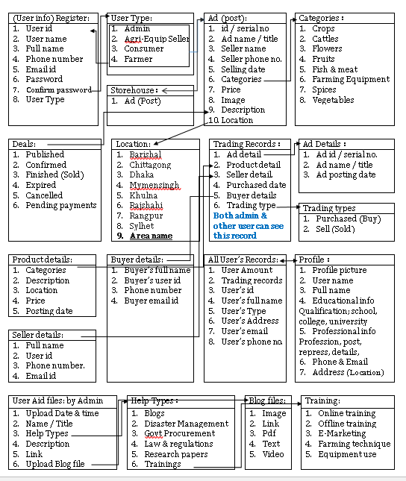

**5.7 User Interface:**

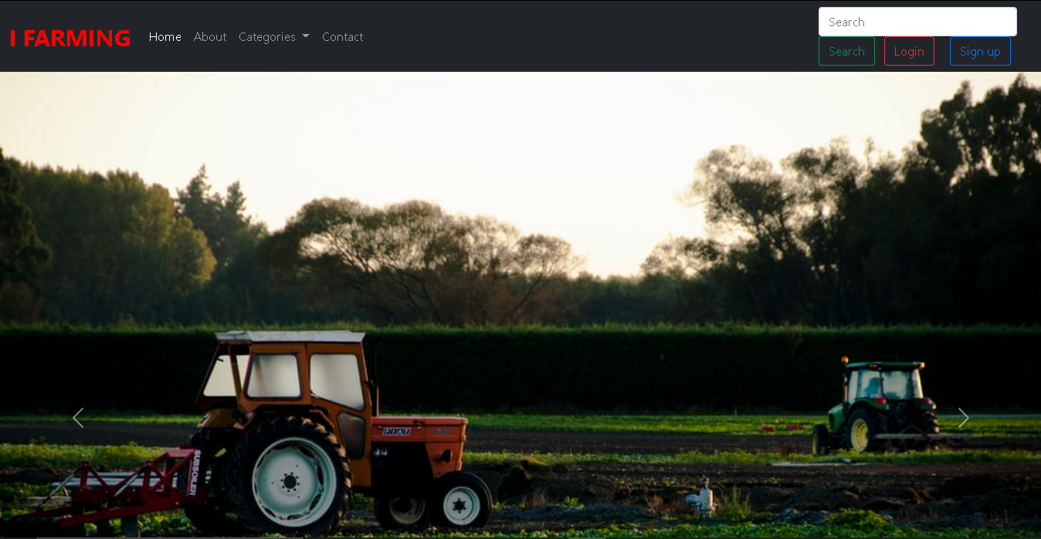

Figure: HOMEPAGE

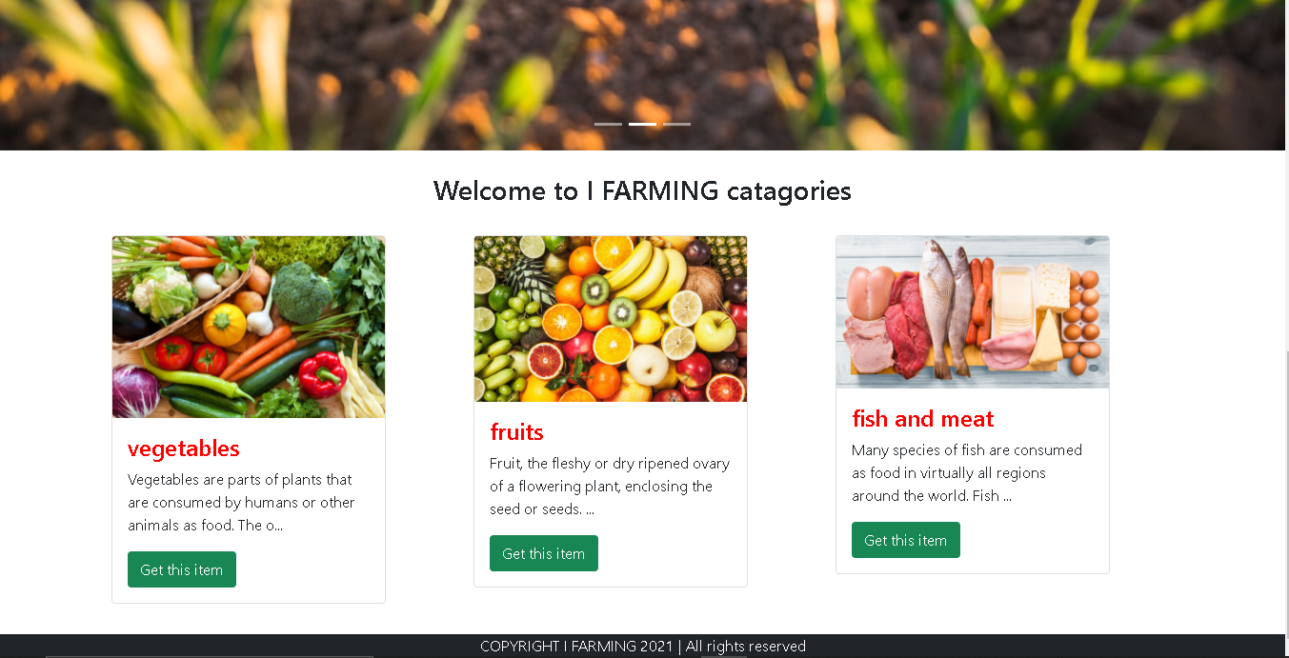Figure: CATAGORIES

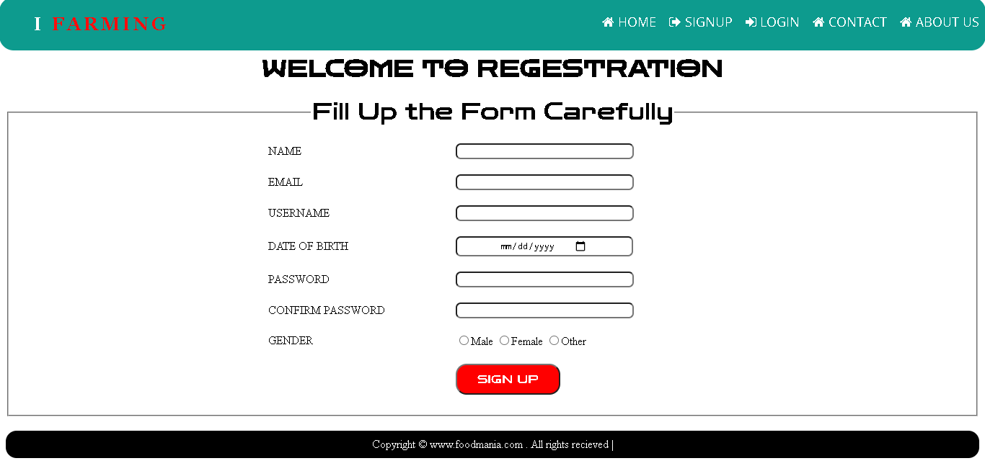

Figure: SIGN UP

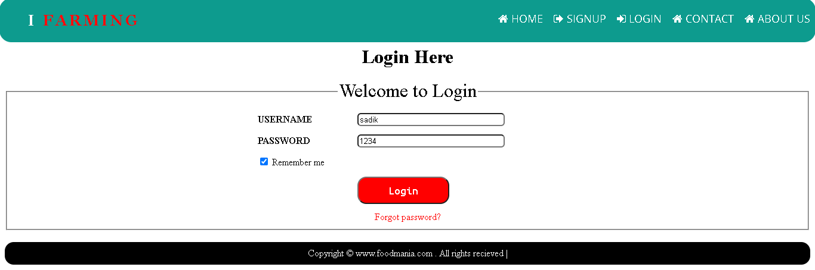

Figure: LOGIN

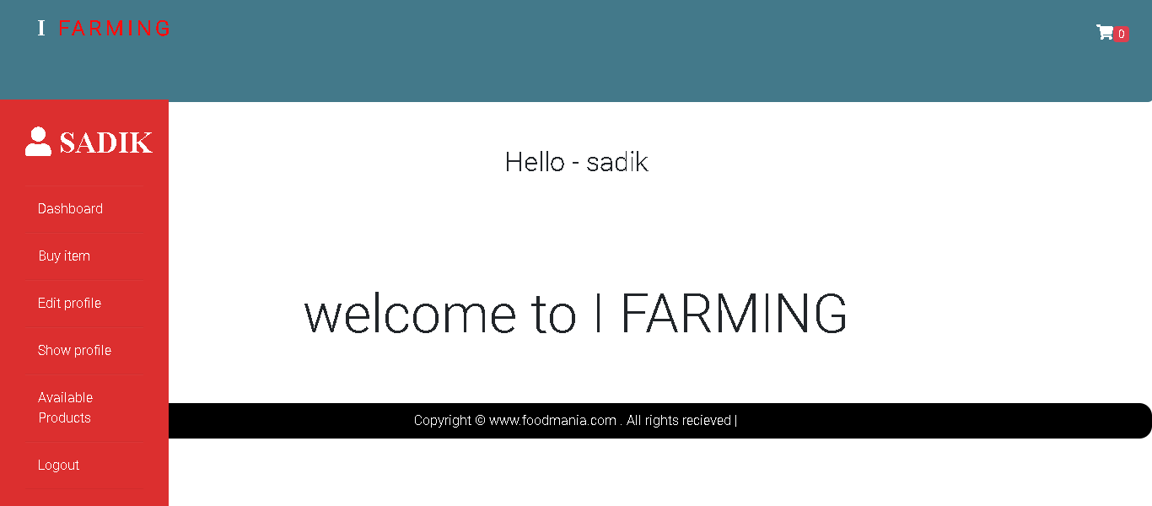Figure: DASHBOARD

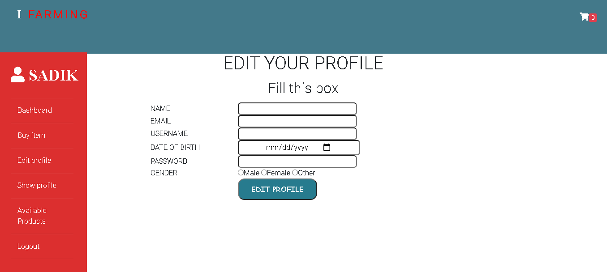 Figure: EDIT PROFILE

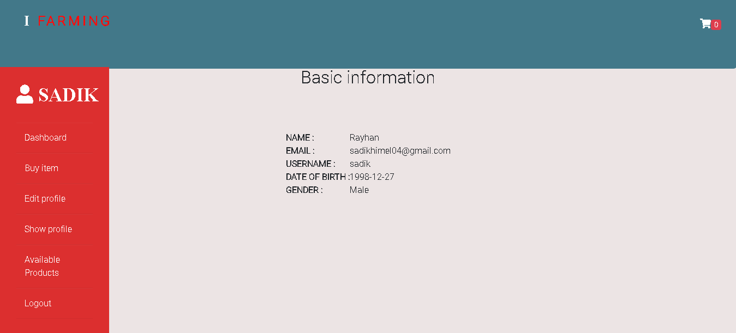

Figure: SHOW PROFILE

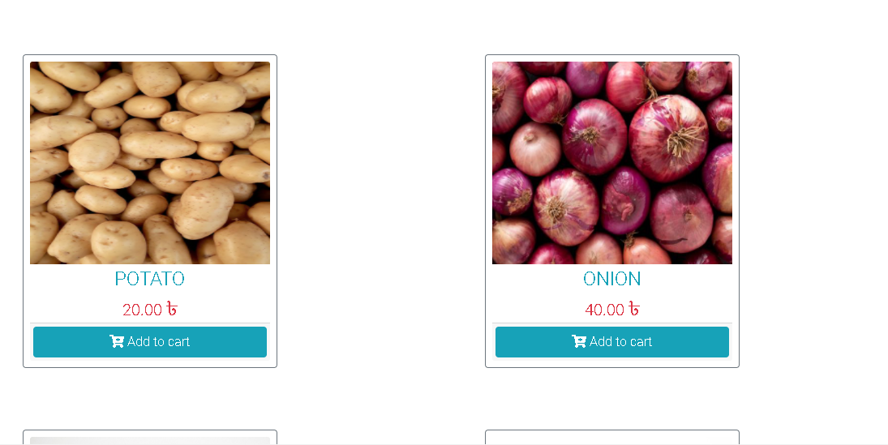

Figure: BUY ITEM

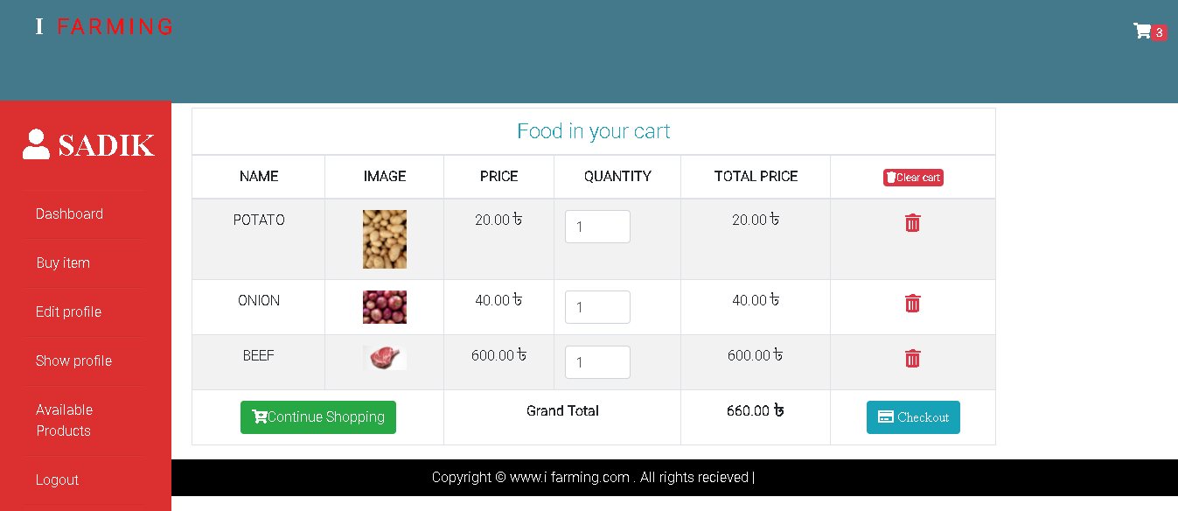

Figure: CART

**Conclusion**: Smart devices such as smart phone tabs could be a true breakthrough for smallholder farmers where apps are used for agricultural marketing. Digital Agricultural Marketing will play a vital role in the years to come in doubling the farmers produce and tripling the Income of the farmers. Creates an awareness on the market prices and the demand of the crop produce. Most immediate benefits of ICT solutions to smallholder farmers is reducing transport and logistics costs for obtaining market information.

**References:**

1. <https://agrimp.com/>
2. <https://ifarmer.asia/>
3. <https://www.bighaat.com/>
4. <https://www.agribazaar.com/searchresult>
5. <https://www.researchgate.net/publication/250212260_Crop_Agriculture_of_Bangladesh_Challenges_and_Opportunities>